Dollar Index
The US Dollar Index measures the value of the USD relative to a basket of six foreign currencies. Euro has the highest weight (58 percent), followed by the Japanese yen (14 percent) and pound sterling (12 percent).
The INR is not in this basket of currencies, but any change in the dollar index has an implication on its value. With the depreciation/appreciation of INR, fund flow in India’s equity market, the profitability of companies in import and export business, dollar-denominated corporate debt, and commodities are all impacted.
When the dollar index rises, INR falls relative to the USD and vice-versa. When the dollar index is falling, FII/FPIs get higher returns in terms of dollar and vice-versa.
Further, it has been observed that historically, commodity prices have had an inverse relationship to the dollar index.
Intuitively, the prices of gold moves in the opposite direction to that of the dollar index. However, over the last two years, the trend has not held true.
This is because, during any uncertainty in the global economy, foreign investors generally increase their portfolio allocation towards safer assets like gold and US Treasury bonds.
This leads to a higher demand for USD and a rise in the dollar index. Considering that India, according to a DEA report, owes $518 billion as external debt (at end-December 2018), a strong dollar index can impact their repayment.
On the sectoral front, depreciating INR benefits the bottom line of companies exporting goods or services. In India, IT and Pharma companies receive higher revenue in USD terms.
IT companies receive more than 50 percent of total revenue from US. The Nifty IT index was a top gainer and rose more than 35 percent last year.
A 1 percent depreciation of INR translates to an increase of 25-35bps of EBITDA margins of IT companies. But, most Indian IT companies hedge currency positions to safeguard against rupee appreciation, which translates to a lower impact.
In a nutshell, there is a direct implication of the dollar index on INR/USD. But, in a few instances, the impact has been low as the dollar index strengthened due to weakening of euro (that has a high weight in dollar index).
Also, even though the profitability of IT and Pharma stocks are impacted by changes in the dollar index, long-term factors like the end market growth and deal wins and their impact on revenue growth are bigger stock price drivers.

Crude Oil
US 10 Year Yield
Treasury bond yields (or rates) are tracked by investors for many reasons. The yields are paid by the U.S. government as interest for borrowing money via selling the bond. But what does this mean, and how do you find yield information?
Treasury Bills are loans to the federal government that mature at terms ranging from a few days to 52 weeks.1 A Treasury Note matures in two to 10 years, while a Treasury Bond matures in 20 or 30 years.23
The 10-year Treasury yield is closely watched as an indicator of broader investor confidence. Because Treasury bills, notes, and bonds carry the full backing of the U.S. government, they are viewed as the safest investment.
Why Is the 10-Year Treasury Yield So Important?
The importance of the 10-year Treasury bond yield goes beyond just understanding the return on investment for the security. The 10-year is used as a proxy for many other important financial matters, such as mortgage rates.
This bond also tends to signal investor confidence. The U.S Treasury sells bonds via auction and yields are set through a bidding process.5
When confidence is high, prices for the 10-year drop, and yields rise. This is because investors feel they can find higher-returning investments elsewhere and do not feel they need to play it safe.
But when confidence is low, bond prices rise and yields fall, as there is more demand for this safe investment. This confidence factor is also felt outside of the U.S. The geopolitical situations of other countries can affect U.S. government bond prices, as the U.S. is seen as safe haven for capital. This can push up prices of U.S. government bonds as demand increases, thus lowering yields.
Another factor related to the yield is the time to maturity. The longer the Treasury bond's time to maturity, the higher the rates (or yields) because investors demand to get paid more the longer their money is tied up. Typically, short-term debt pays lower yields than long-term debt, which is called a normal yield curve. But at times the yield curve can be inverted, with shorter maturities paying higher yields.

US Stock Market Indices and Futures
Asian Market
European Market
SGX NIFTY
Manufacturing PMI Data
Inflation Data
Inflation is a sustained increase in the general prices of goods and services. Increasing inflation erodes the purchasing power of money. All things being equal, if the cost of 1 KG of onion has increased from Rs.15 to Rs.20, then this price increase is attributed to inflation. Inflation is inevitable, but a high inflation rate is not desirable as it could lead to economic uneasiness. A high level of inflation tends to send a bad signal to markets. Governments work towards cutting down the inflation to a manageable level. Inflation is generally measured using an index. If the index is going up by certain percentage points, it indicates rising inflation, likewise index falling indicates inflation cooling off.
There are two types of inflation indices – Wholesale Price Index (WPI) and Consumer Price Index (CPI).
Wholesale Price Index (WPI) – The WPI indicates the movement in prices at the wholesale level. It captures the price increase or decreases when they are sold between organizations as opposed to actual consumers. WPI is an easy and convenient method to calculate inflation. However, the inflation measured here is at an institutional level and does not necessarily capture the consumer’s inflation.
As I write this, the WPI inflation for May 2014 stands at 6.01%.
Consumer Price Index (CPI)– The CPI, on the other hand, captures the effect of the change in prices at a retail level. As a consumer, CPI inflation is what really matters. The calculation of CPI is quite detailed as it involves classifying consumption into various categories and subcategories across urban and rural regions. Each of these categories is made into an index. This means the final CPI index is a composition of several internal indices.
The computation of CPI is quite rigorous and detailed. It is one of the most critical metrics for studying the economy. A national statistical agency called the Ministry of Statistics and Programme Implementation (MOSPI) publishes the CPI numbers around the 2nd week of every month.
The CPI stands at 8.28% for May 2014. Here is a chart for the inflation for the last one year in India.
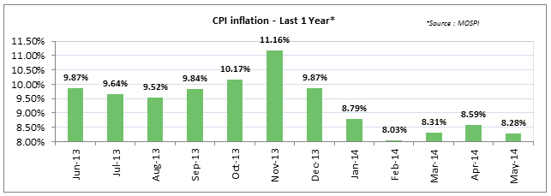
As you can notice, the CPI inflation had kind of cooled off from a peak of 11.16% in November 2013. The RBI’s challenge is to strike a balance between inflation and interest rates. Usually, a low-interest rate tends to increase inflation, and a high-interest rate tends to arrest inflation.

US Jobs Data
India Export Import Data
USDINR
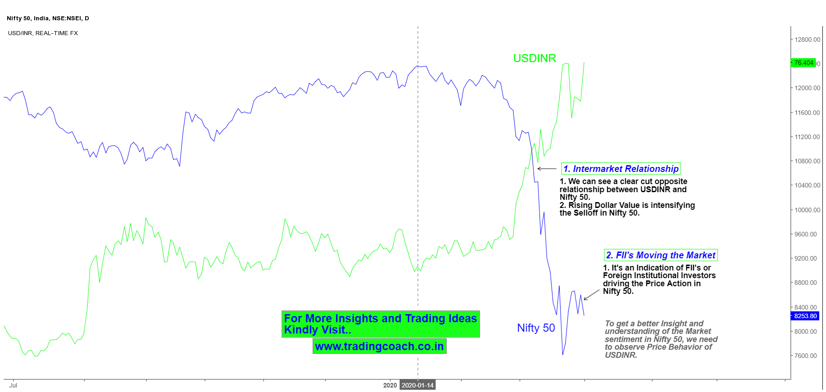
Over the past decade, we have seen the INR value versus the dollar and the Nifty moving in tandem on many occasions. Take the case of 2008 when the INR crashed from 42/$ to 50/$ even as the Nifty and the Sensex fell vertically. Then again in 2013 when the US Fed first hinted at a tapering of its bond portfolio, the INR literally crashed from a level of 53/$ to around 68/$ in a span of a few days. This period was also marked by a sharp correction in the Nifty and the Sensex. To get a better picture of the phenomenon, we have plotted the USD/INR exchange rate with the movement of the Sensex over the last five years. So what exactly can we infer from the chart below? If one looks at the last five years performance, the connection between the exchange rate and the Nifty has not been too clear. During the five year period, the INR has depreciated by about (-13.5%) but during the same period the Nifty gave a positive return of over 89%. This huge divergence obviously raises some serious questions over whether there is any relationship between the INR strength and the Nifty returns over the longer term. Why do the currency and INR/USD equation appear to diverge in the long term? As we said earlier, we are being largely intuitive but the message seems to be that the Nifty is not overly dependent on the INR/USD currency over the longer term. Here are 3 key reasons why the currency and the Nifty have diverged over a five year period. If you look at the weightage of the Nifty, the biggest weightage belongs to banking, which is not exactly impacted by the INR/USD movements in a big way. Among the key sectors there are heavy weights like Information Technology and pharma as well as small sectors like auto ancillaries that actually benefit from a weak rupee. These 3 sectors are export-driven sectors and exports tend to benefit from a weak rupee. That is because a weak rupee makes the Indian products cheaper for the foreign customer as they can buy more with the same amount of dollars. There are other sectors like oil, capital goods, autos and metals that benefit from a strong rupee. But the bottom-line is that there are enough companies in the Nifty that benefit from a strong rupee as also from a weak rupee. The linkage between the INR/USD equations was brought out by the FII activity in equity markets. FII activity impacts the equity market and the currency market and that used to be the link. But two subtle shifts have happened in the last few years. Firstly, with the government permitting FIIs to invest in sovereign and corporate debt in a big way, many FIIs prefer to take the debt route while underplaying the equity route. The demand for Indian debt is driven by the yield spread between the US benchmark and the Indian benchmark. Secondly, domestic mutual funds investment have become a potent force and have been infusing over $10 billion into equities each year. This has also weakened the relationship between the Nifty and the INR/USD movement. Lastly, India has managed to put its macros in order through a fiscal discipline focus under the current government. As a result, FDI inflows have picked up sharply and today India attracts more FDI annually than China. Therefore, India’s USD/INR is not overly dependent on the FII flows alone, which has reduced the correlation between the currency and the Nifty. But the short term convergence is still evident If one were to intuitively look at the relationship between the Nifty and the INR/USD over a shorter period, the relationship appears to be quite strong around pivots. As mentioned earlier, around pivot points markets are driven more by sentiments and short term data rather than long term valuation measures. Hence the correlation between the INR/USD and the Nifty becomes more pronounced. We have seen that in 2008 and again in 2013, when on the downside there was a clear correlation between the fall in the rupee and the fall in the Nifty. Post 2016, it has worked on the positive with a strong rupee accompanying a robust Nifty index. What explains the causality? This is more due to the vicious / virtuous cycle impact. For example, when the FIIs sell aggressively, the impact shows quiet clearly on the Nifty values. At the same time FIIs are also converting their INR into dollars which increases the demand for the dollar. That is when the spiral effect takes off. The action of FIIs forces banks, importers and FCNR borrowers to also run for cover. That is how a vicious cycle gets into place. This takes time to stabilize and during this phase, we can see a positive correlation between the INR/USD and the Nifty. The crux of the story is that over the long run the Nifty is driven more by structural and fundamental factors. But in the short term, the INR and the Nifty do tend to correlate positively. That is the distinction that one needs to apprehend!

FII DII Data
Monetary Policy (RBI Policy)
The monetary policy is a tool with which the Reserve Bank of India (RBI) controls the money supply by controlling the interest rates. They do this by tweaking the interest rates. RBI is India’s central bank. The world over every country’s central bank is responsible for setting interest rates.
While setting the interest rates, the RBI has to strike a balance between growth and inflation. In a nutshell – if the interest rates are high, that means the borrowing rates are high (particularly for corporations). If corporate can’t borrow easily, they cannot grow. If corporations don’t grow, the economy slows down.
On the other hand, when the interest rates are low, borrowing becomes easier. This translates to more money in the hands of corporations and consumers. With more money, there is increased spending which means the sellers tend to increase prices leading to inflation.
To strike a balance, the RBI has to consider all the factors and carefully set a few key rates. Any imbalance in these rates can lead to economic chaos. The key RBI rates that you need to track are as follows:
Repo Rate – Whenever banks want to borrow money, they can borrow from the RBI. The rate at which RBI lends money to other banks is called the repo rate. If the repo rate is high, that means the cost of borrowing is high, leading to slow growth in the economy. Currently, the repo rate in India is 8%. Markets don’t like the RBI increasing the repo rates.
Reverse repo rate – Reverse Repo rate is the rate at which RBI borrows money from banks. When banks lend money to RBI, they are certain that RBI will not default, and hence they are happier to lend their money to RBI as opposed to a corporate. However, when banks choose to lend money to the RBI instead of the corporate entity, the banking system’s supply of money reduces. An increase in reverse repo rate is not great for the economy as it tightens the supply of money. The reverse repo rate is currently at 7%.
Cash reserve ratio (CRR) – Every bank is mandatorily required to maintain funds with RBI. The amount that they maintain is dependent on the CRR. If CRR increases, then more money is removed from the system, which is not good for the economy.
The RBI meets every two months to review the rates. This is a key event that the market watches out for. The first to react to rate decisions would be interest-rate sensitive stocks across various sectors such as – banks, automobile, housing finance, real estate, metals, etc.
Index of Industrial Production (IIP)
The Index of Industrial Production (IIP) is a short-term indicator of how the country’s industrial sector is progressing. The data is released every month (along with inflation data) by the Ministry of Statistics and Programme Implementation (MOSPI). As the name suggests, the IIP measures the Indian industrial sectors’ production, keeping a fixed reference point. As of today, India uses the reference point of 2004-05. The reference point is also called the base year.
Roughly about 15 different industries submit their production data to the ministry, which collates the data and releases it as an index number. If the IIP is increasing it indicates a vibrant industrial environment (as the production is going up) and hence a positive sign for the economy and markets. A decreasing IIP indicates a sluggish production environment, hence a negative sign for the economy and markets.
To sum up, an upswing in industrial production is good for the economy, and a downswing rings an alarm. As India is getting more industrialized, the relative importance of the Index of Industrial Production is increasing.
A lower IIP number puts pressure on the RBI to lower the interest rates. The following graph shows the change in IIP in percentage terms for the last 1 year.
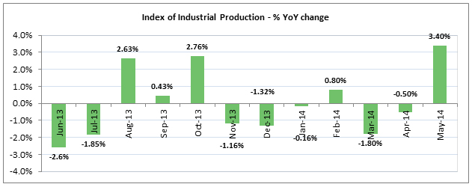
Purchasing Managers Index (PMI)
The Purchasing managers’ index (PMI) is an economic indicator that tries to capture business activity across the country’s manufacturing and service sectors. This is a survey-based indicator where the respondents – usually the purchasing managers- indicate their business perception change concerning the previous month. A separate survey is conducted for the service and the manufacturing sectors. The data from the survey are consolidated on a single index. Typical areas covered in the survey include new orders, output, business expectations, and employment.
The PMI number usually oscillates around 50. A reading above 50 indicates expansion, and below 50 indicates a contraction in the economy. And reading at 50 indicates no change in the economy.
Corporate Earnings Announcement
This is perhaps one of the important events to which the stocks react. The listed companies (trading on the stock exchange) must declare their earning numbers once in every quarter, also called the quarterly earnings numbers. During an earnings announcement, the corporate gives out details on various operational activities, including:
- How much revenue has the company generated?
- How has the company managed its expense?
- How much money they did the company pay in terms of taxes and interest charges?
- What is the profitability during the quarter?
Besides some companies give an overview of what they expect from the upcoming quarters. This forecast is called ‘corporate guidance’.
Invariably every quarter, the first blue-chip company to make the quarterly announcement is Infosys Limited. They also give out guidance regularly. Market participants keenly follow what Infosys has to say in terms of guidance as it has an overall impact on the markets.
The table below gives you an overview of the earning season in India:
Sl No | Months | Quarter | Result Announcement
01 | April to June | Quarter 1 (Q1) | 1st week of July
02 | July to September | Quarter 2 (Q2) | 1st week of Oct
03 | October to December | Quarter 3 (Q3) | 1st Week of Jan
04 | January to March | Quarter 4 (Q4) | 1st Week of April
Every quarter when the company declares its earnings, the market participants match the earnings with their own expectation of how much the company should have earned. The market participant’s expectation is called the ‘street expectation’.
The stock price will react positively if the company’s earnings are better than street expectation. On a similar logic, the stock price will react negatively if the actual numbers are below the street expectation.
If the street expectation and actual numbers match, the stock price tends to trade flat with a negative bias more often than not. This is mainly because the company could not give any positive surprises.

Corporate actions are initiatives taken up by a corporate entity that brings in a change to its stock. There are many types of corporate actions that an entity can choose to initiate. A good understanding of these corporate actions gives a clear picture of the company’s financial health and determines whether to buy or sell a particular stock.
This chapter will be looking into the five most important corporate actions and their impact on stock prices.
A corporate action is initiated by the board of directors and approved by the company’s shareholders.
- Dividends
The company pays dividends to its shareholders. Dividends are paid to distribute the profits made by the company during the year. Dividends are paid on a per-share basis. For example, during the financial year, 2012-13 Infosys had declared a dividend of Rs.42 per share. The dividend paid is also expressed as a percentage of the face value. In the above case, the face value of Infosys was Rs.5/- and the dividend paid was Rs.42/- hence the dividend payout is said to be 840% (42/5).
It is not mandatory to pay out dividends every year. If the company feels that instead of paying dividends to shareholders, they are better off utilizing the same cash to fund a new project for a better future, they can do so.
Besides, the dividends need not be paid from the profits alone. If the company has made a loss during the year, but it does hold a healthy cash reserve, then the company can still pay dividends from its cash reserves.
Sometimes distributing the dividends may be the best way forward for the company. When the company’s growth opportunities have exhausted, and the company holds excess cash, it would make sense for the company to reward its shareholders, thereby repaying the trust the shareholders hold in the company.
The decision to pay a dividend is taken in the Annual General Meeting (AGM) during which the directors of the company meet. The dividends are not paid right after the announcement. This is because the shares are traded throughout the year, and it would be difficult to identify who gets the dividend and who doesn’t. The following timeline would help you understand the dividend cycle.

Dividend Declaration Date: This is the date on which the AGM takes place, and the company’s board approves the dividend issue
Record Date: This is when the company decides to review the shareholders register to list down all the eligible shareholders for the dividend. Usually, the time difference between the dividend declaration date and the record date is 30 days.
Ex-Date/Ex-Dividend date: The ex-dividend date is normally set two business days before the record date. Only shareholders who own the shares before the ex-dividend date are entitled to the dividend. This is because, in India, the normal settlement is on a T+2 basis. So for all practical purposes, if you want to be entitled to receive a dividend, you need to ensure you buy the shares before the ex-dividend date.
Dividend Payout Date: This is when the dividends are paid out to shareholders listed in the register of the company.
Cum Dividend: The shares are said to be cum dividend till the ex-dividend date.
When the stock goes ex-dividend, usually the stock drops to the extent of dividends paid. For example, if ITC (trading at Rs. 335) has declared a dividend of Rs.5. On ex-date, the stock price will drop to the extent of dividend paid, and as in this case, the price of ITC will drop down to Rs.330. The reason for this price drop is because the amount paid out no longer belongs to the company.
Dividends can be paid anytime during the financial year. If it’s paid during the financial year, it is called the interim dividend. If the dividend is paid at the end of the financial year, it is called the final dividend.
- Bonus Issue
A bonus issue is a stock dividend, allotted by the company to reward the shareholders. The bonus shares are issued out of the reserves of the company. These are free shares that the shareholders receive against shares that they currently hold. These allotments typically come in a fixed ratio such as 1:1, 2:1, 3:1, etc.
If the ratio is 2:1 ratio, the existing shareholders get 2 additional shares for every 1 share they hold at no additional cost. So if a shareholder owns 100 shares, he will be issued an additional 200 shares, so his total holding will become 300 shares. When the bonus shares are issued, the number of shares the shareholder holds will increase, but an investment’s overall value will remain the same.
To illustrate this, let us assume a bonus issue on different ratios – 1:1, 3:1 and 5:1

Bonus Issue | No of shares held before bonus. | Share price before Bonus issue | Value of Investment | Several shares held after Bonus. | Share price after Bonus issue | Value of Investment
1:1 | 100 | 75 | 7,500 | 200 | 37.5 | 7500
3:1 | 30 | 550 | 16,500 | 120 | 137.5 | 16,500
5:1 | 2000 | 15 | 30,000 | 12,000 | 2.5 | 30,000
There is a bonus announcement date, ex-bonus date, and record date similar to the dividend issue.
Companies issue bonus shares to encourage retail participation, especially when the company’s price per share is very high, and it becomes tough for new investors to buy shares. By issuing bonus shares, the number of outstanding shares increases, but each share’s value reduces, as shown in the example above. The face value remains unchanged.
- Stock Split
For the first time, the word stock split sounds weird, but this happens regularly in the markets. What this means is quite obvious – the stocks that you hold actually are split!
When the company declares a stock split, the number of shares held increases, but the investment value/market capitalization remains similar to the bonus issue. The stock is split concerning the face value. Suppose the stock’s face value is Rs.10, and there is a 1:2 stock split then the face value will change to Rs.5. If you owned 1 share before the split, you would now own 2 shares after the split.
We will illustrate this with an example:

Split Ratio | Old FV | No of shares you own before split | Share Price before split | Investment Value before split | New FV | No of shares you own after the split | Share Price after the split | Investment value after the split
1:2 | 10 | 100 | 900 | 90,000 | 5 | 200 | 450 | 90,000
1:5 | 10 | 100 | 900 | 90,000 | 2 | 500 | 180 | 90,000
Like a bonus issue, a stock split is usually to encourage more retail participation by reducing the value per share.

- Rights Issue
The idea behind a rights issue is to raise fresh capital. However, instead of going public, the company approaches its existing shareholders Think about the rights issue as a second IPO and a select group of people (existing shareholders). The rights issue could be an indication of promising new development in the company. The shareholders can subscribe to the rights issue in the proportion of their shareholding. For example, 1:4 rights issue means every 4 shares a shareholder owns; he can subscribe to 1 additional share. Needless to say, the new shares under the rights issue will be issued at a lower price than what prevails in the markets.
However, a word of caution – The investor should not be swayed by the company’s discount, but they should look beyond that. A rights issue is different from a bonus issue as one is paying money to acquire shares. Hence the shareholder should subscribe only if he or she is completely convinced about the company’s future. If the market price is below the subscription price/right issue price, it is obviously cheaper to buy it from the open market.
Buyback of shares
A buyback can be seen as a company’s method to invest in itself by buying shares from other investors in the market. Buybacks reduce the number of shares outstanding in the market; however, buyback of shares is an important corporate restructuring method. There could be many reasons why corporates choose to buy back shares…
- Improve the profitability on a per-share basis
- To consolidate their stake in the company.
- To prevent other companies from taking over.
- To show the confidence of the promoters about their company.
- To support the share price from declining in the markets.
When a company announces a buyback, it signals the company’s confidence about itself. Hence this is usually positive for the share price.

